

TENANCY AGREEMENT
BETWEEN COURTLAND REALTORS
LIMITED

REGISTERED

REAL ESTATE MANAGEMENT, SALES, AND INVESTMENT CONSULTANCY
POST OFFICE BOX: 11993 –
00100, NAIROBI ACTING ON BEHALF OF,
NJENY SUITES (LANDLORD)
OFFICES IN: RUAKA SUITE C3 2ND FLOOR UPENDO HOUSE (KARIUKI DRIVE).
TEL: 0703759351/0723575686
AND
MR/MRS/MISS Samantha Ariri Opudo

An agreement made on 2nd August 2025. (Two thousand and twenty-five.) BETWEEN Courtland Realtors Limited (hereinafter referred to as the which expression shall where the context so admits include her personal representatives, executors and assigns) MR/MRS/MISS Samantha Ariri Opudo of ID NO: 31869737 TEL NO 0729178062 (hereinafter
referred to as the “TENANT” which expression shall where the context so admits include her
personal representatives and assigns)of the Apartment suite number 204

APPOINTMENT
  - The Landlord is now the owner All THAT piece or parcel of land.
  - The Managing Agents on behalf of the Landlord has agreed to lease the unit under reference in the aforesaid premises to the tenant.

TERM
The Managing Agents, on behalf of the Landlord, shall let and the Tenant shall take ALL THAT
dwelling house number 204 TO HOLD the same from: 1st September to 31st August 2025 and renewable with the same terms.
- RENT
- The exclusively monthly rent is Kes 32,000 ONLY.
- This will be paid to the Landlord account and an official receipt MUST be given to the tenant for all payments as proof of payment. Any claim of payment without a receipt shall not be entertained.
- Rent is payable in cash banked into the Landlords Bank account attached hereby
PAYBILL 222111
ACCOUNT 2716280.
ACCOUNT NAME: NJEKIRU LIMITED

- PROVIDED ALWAYS AND IT IS HEREBY AGREED by and between the parties thereto THAT if said rent or other payment due hereunder or any part thereof shall remain unpaid after 5th of the stay month, the tenant will be liable to pay 10% as late remittance charge and the same shall be constructed as additional rent and further be liable for all expenses should further action, such as distress for rent be taken. Such action may be taken immediately after the 10th day of the month without any reference to the tenant, disconnection of water will be done on 11th of every month whenever payments are not received.

DEPOSIT

- At the commencement of the tenancy the tenant will be required to pay a deposit
of one month’s rent of Kes 32,000.
- And the Landlord shall retain the same for the entire period of tenancy as security for house repair /repainting and bills.
- THE DEPOSIT SHALL NOT AT ANY TIME BE OFFSET AGAINST
UNPAID RENTS but rather will be held as security for house repairs and bills as specified in (i) above ,and will be refunded AFTER the tenant has vacated the premises leaving it in the required state. The said deposit shall not attract any interest. As soon
As the inspection is done and the agent satisfied with the condition of the premises, in terms of repairs, painting and payment of bills, deposit held shall be refunded to the tenant.

DURING THE TENANCY HEREBY CREATED THE TENANT SHALL;-
- Pay the rent payable hereunder at the time and in the manner fore-said as may be directed.
- Pay all electricity, water, conservancy and telephone (if any) charges incurred by the Tenant.
- To use only electric or gas cookers and not to use charcoal or paraffin or other means of cooking in the demised premises
- Keep internal parts of the dwelling house including all doors, windows, water taps, basins, sanitary apparatus, electric light fittings and other landlord’s fixtures and all hedges, ditches, fences and gates on the demised premises in the same state of good and tenant-able repair and condition as the same now are fair, wear and tear only exempted.
- Keep the drains both interior and exterior at all times free from obstructions and in proper working order.
- Permit the Landlord or his Managing Agents at all reasonable times during the said tenancy upon giving reasonable notice with or without workmen or others to enter upon and examine the condition of the said premises
- Permit the Landlord or his Managing Agent with all necessary workmen and appliances at all reasonable times during the day to enter the said premises for the purpose of carrying out any repairs of which the Landlord may be liable under the provisions hereof.

- Not to make any alterations in or addition to any of the said premises or carry out any improvements permanent or temporary , upon the said premises or any part thereof save with the written consent of the Landlord first hand and obtained, which consent shall not be unreasonably withheld.

- Not to drive any nails, screws, bolts or wedges in any of the walls, timbers, ceilings or floors of the said premises nor the Landlord’s fixtures and fittings therein nor permit the same to be done save with written consent of the Landlord or the Managing Agents.
- Not to assign, sublet or otherwise part with possession of the said premises or any part thereof without the consent in writing of the Landlord or the Managing Agents first hand and obtained.
- Not do or suffer to be done anything on the said premises which may render any increased or extra premium for the insurance of the said building against fire or which may void any policy for such insurance held by the Landlord

- To take every reasonable precaution to ensure those white ants or other destructive insects does not gain access to the said premises and to notify the Landlord or his Agent of any infestations appearing.
- Not to permit or suffer to be done anything whereby any insurance of the demised premises against loss or damage by fire may become void.
- The tenant will be responsible for all the keys to the House, which should be returned to the Managing Agents office when the House is vacated.
- The tenants shall ensure quiet living and not to be of nuisance to neighbors. This is mainly by keeping music instruments at reasonable low levels not to cause annoyance to other tenants and the general public.
- The agent or Landlord will not suffer any Loss incurred inform of theft or burglary as the tenant is required to insure his or her properties.

DURING THE TENANCY HEREBY CREATED THE LANDLORD SHALL;-
- Keep the foundations, walls and external part of the dwelling house, main driveways, main waterlines gutters, down pipes, main electric lines and main sewage lines in good and tenant-able repair and condition.
- Subject to the Tenant paying the rent payable hereunder and performing and observing the agreements stipulations and conditions herein contained or implied and on his part to be performed and observed allow the tenant peaceably and quietly to possess and enjoy the said premises without any interruption from or by the Landlord or any person rightly claiming from or under him.

TERMINATION
  - If either party shall desire to terminate the term hereby created and shall give to the other party ONE MONTH CALENDAR NOTICE with effect from 30th day of that month in writing of such desire, then immediately on the expiration of such notice the present tenancy shall cease without prejudice to rights or remedies of either party against the other in respect of any antecedent breach of covenant, NO DEPOSIT REFUND WILL BE APPLICABLE WITHOUT SUCH NOTICE

TENANCY RENEWAL
Upon expiration of the tenancy period and subject to the provisions of early termination herein contained, this agreement shall be deemed to be automatically renewed for consecutive periods of one year each unless terminated in accordance with the above provisions, or renewed for a further term on such terms and conditions as the parties herein may determine.
IN WITNESS WHEREOF the tenant and the MANAGING Agents have to set their respective hands signatures the day and year herein above written

SIGNED by Tenant
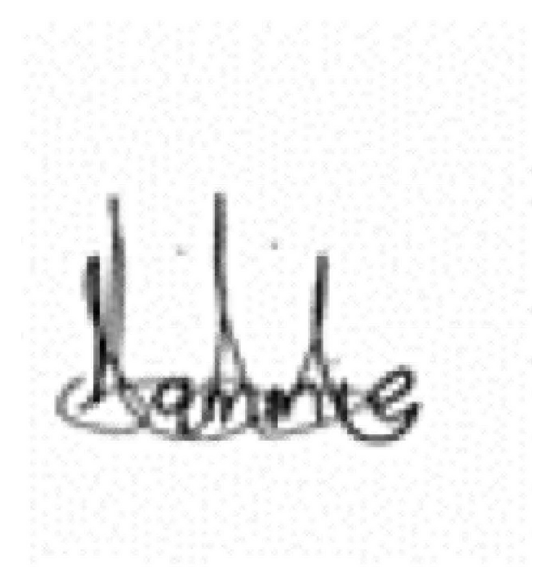
NAME:…Samantha Ariri Opudo
… (Signed)
ID NO:31869737
NATURE OF WORK: Project Coordinator
TELL NO: 0729178062
NEXT OF KIN NAME: Ludfine Bunde
TELL NO: 0710622622
SIGNED for and on behalf of Landlord
COURTLAND REALTORS LIMITED
In presence of

NAME: Kevin Maywaka
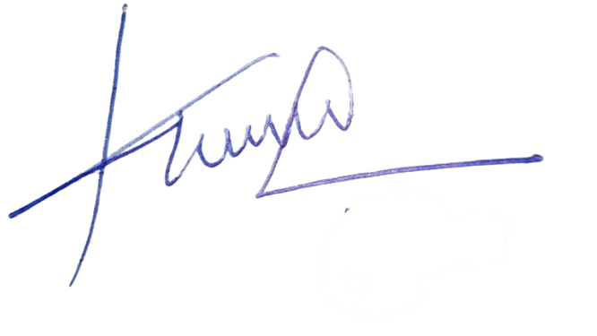
Designation: Managing Agent
… (Signed)

